EXODUS

Message:

“God establishes a relationship with the nation Israel by redeeming them and providing for them the means to maintain and, if necessary, restore this relationship.”

Title:

“Exodus” is a Latin word derived from Greek [Exodoı (Exodos), the name given to the book in the Septuagint. The word means “exit, going out, or departure.” In Hebrew the book is named after its first two words, twmv hlaw [we'elleh shemoth ] (“These are the names of”). The same phrase occurs in Gen 46:8, where it likewise introduces a list of the names of those Israelites “who went to Egypt with Jacob” (Exod 1:1). Both from context and from the conjunction standing first in the Hebrew of 1:1, it is clear that Exodus was not intended to exist separately, but was thought of as a continuation of a narrative that began in Genesis.

Author:

See Genesis: Author.

In addition, several statements in Exodus specifically indicate that Moses wrote certain sections of the book (17:14; 24:4; 34:27). Joshua 8:31 refers to the command of Exodus 20:25 as having been “written in the Book of the Law of Moses.” The New Testament also claims Mosaic authorship for various passages in Exodus (e.g., Mark 7:10; 12:26; Luke 2:22-23). Taken together, these references strongly suggest that Moses was largely responsible for writing the book of Exodus. Christ and the apostles quote Exodus twenty-five times.

Evidence from Exodus itself suggests that the author was a highly educated man, who knew both Egypt and the Sinai and was an eyewitness of the Exodus (e.g., Exod 5:6; 15:27; 25:5). Moses, of course, is all of these.

Recipient:

See Genesis: Recipient.

Historical Context:

The historical setting of Exodus centers of the land of Egypt, from which the exodus of the Hebrews took place, and the Sinai Peninsula through which the Hebrews journeyed on their way to Mount Sinai.

The history of Israel is intertwined with the history of Egypt. Scholars designate Ancient Egypt’s history in three periods referred to as the predynastic period (3500-3100 B.C.), the protodynastic period (3100-2686 B.C.), and the dynastic period (2686-322 B.C.). The dynastic period is broken down into several intermediate periods. Towards the end of the first intermediate period (taking an early date for the exodus, see below: Date) during the 12th dynasty, Jacob and his sons came to live in Egypt (1876 B.C.; Gen 46:6). Joseph served as a “prime minister” of Egypt to the Pharaoh. This twelfth dynasty is understood as a prosperous time when arts and craftsmanship flourished. The events of Exodus occur in the 18th dynasty after Egypt had attained international status and when Egyptian nationalism supplanted the older Hyksos tolerance of foreigners.

Since Israel sojourned in Egypt 430 years (Exod 12:40), Jacob’s entrance into the land occurred in 1876 B.C. during the reign of Sesostris III (1878-1841 B.C.). Joseph died during the reign of Amenemhet III in 1805 B.C. Depending on who is to be identified as “the king who knew not Joseph” (Exod 1:8), the Hebrews may have lived their first two hundred years in peace under the foreign rulership of the Semitic Hyksos who ruled Egypt from 1730-1580 B.C. Ahmoses (1850-1548 B.C.) founded the eighteenth dynasty may have been the Pharaoh who first initiated the official oppression of the Hebrews. Amenhotep I (1548-1528 B.C.) was probably the Pharaoh who developed the oppressive measures as recorded in Exodus 1:22. Thutmoses I (1528-1508 may have been the father of Hatshepsut who rescued Moses (Exod 2:5). Amenhotep II was most likely the Pharaoh during the actual exodus from Egypt (Exod 5:1-2). This identification of the Pharaohs who interacted with Israel must be tentative and would be debated by many, even conservative scholars.

Date of Material Presented:

The date of writing depends to a great extent, of course, on the date of the exodus itself. It is likely that Exodus was written at the end of the stay at Mount Sinai, certainly before the end of the wilderness journey and the death of Moses.

The date of the Exodus centers around two main views: an early (around 1446 B.C.) and a late view (around 1266 B.C.). These are arrived at by evaluation of both biblical data and archaeological discoveries.

The biblical data is based primarily on two references: 1 Kings 6:1 and Judges 11:26. According to 1 Kings 6:1, the exodus took place 480 years before “the fourth year of Solomon’s reign over Israel,” the year that the temple dedication took place. Since that year is usually conceded to be c. 966 B.C. (though it is debated by some), it has been traditionally held that the exodus occurred c. 1446 (966 + 480 = 1446). The 480 years are taken as real years, though they are also the same as 12 generations of 40 years each. Genesis 15:13 says, “ . . . Know for certain that your descendants will be strangers in a country not their own, and they will be enslaved and mistreated four hundred years” while Genesis 15:16 says, “In the fourth generation your descendants will come back here . . . .” The four generations should probably be taken as a synonym of the four hundred years since a “generation” was the age of a man when his firs son (from the legal standpoint) was born—in Abram’s case, 100 years (Gen 21:5). The four hundred years are years of slavery and could therefore be speaking of a period after Joseph when “a new king, who did not know about Joseph, came to power in Egypt” (Exod 1:8) which apparently was 30 years after Joseph and his family had moved to Egypt since Exodus 12:40 speaks of Israel living in the land of Egypt for 430 years. The “three hundred years” of Judges 11:26 fits comfortably within this time span if Jephthah lived around 1100 B.C. (see Introduction to Judges: Date) and the 40 years of wilderness living are added in too. In addition, although Egyptian chronology relating to the 18th dynasty remains somewhat uncertain, recent research tends to support the traditional view that two of this dynasty's pharaohs, Thutmose III and his son Amunhotep II, were the pharaohs of the oppression and the exodus respectively.

Those who hold a thirteenth-century B.C. date calculate a generation at 25 years (12 X 25 = 300) and place the exodus around 1266 B.C. They consider the 480 a symbolic statement of time that differs from the actual historical record. They would see the appearance of the name Rameses in 1:11 as demonstrating that the 19th-dynasty pharaoh Seti I and his son Rameses II (1304-1238 B.C.) were the pharaohs of the oppression and the exodus respectively. The appearance of the name Rameses in the biblical record could be the result of an editorial update (as appears also to be the case in Gen 47:11) or it may have been named for another Rameses. Archaeological evidence of the destruction of numerous Canaanite cities in the 13th century B.C. has been interpreted as proof that Joshua’s troops invaded the promised land in that century. There is great difficulty, however, in identifying the cities' attackers and identifying them with the conquest by the Hebrews. Archaeological evidence of destructions have been interpreted variously to point to either an early or late date.

The Merneptah Stela, which notes that Pharaoh Merneptah encountered Israel in Palestine around 1220 B.C., requires the exodus to be dated before 1220 B.C. at the latest. The Amarna letters (around 1400-1366 B.C.) mention the Habiru, who invaded southern and central Palestine. Abdi-Hiba, governor or Jerusalem, wrote numerous letters to Pharaoh Akhnaton (1377-1358 B.C.) requesting Egyptian aid against the encroaching Habiru. If the term “Habiru” either equates or includes the Israelites (Hebrews), then that place the nation of Israel in Palestine quite early. Not all scholars would agree with this connection.

The Bible does not name the pharaoh of the exodus. Extant Egyptians records do not mention Joseph, Moses, or the exodus. Archaeological data can be variously interpreted. The key issue is how the biblical text is interpreted and applied.

Date of Writing:

The book covers a time span of approximately eighty-five years from the birth of Moses to the completion and dedication of the tabernacle at Sinai. Moses must have written Exodus shortly after this, certainly before he died on the Plains of Moab after the forty years of wilderness wandering.

Theological Context:

Exodus contains a number of theologically significant incidents or features. It will provide an account of how the elect Hebrew people (Gen 12:1-3; 15:13-21; 18:18; 22:18; 26:3-4) are formed into an elect nation. The transformation into a theocratic nation is the development of Israel into a kingdom of priests, a holy nation. Though as individuals and as a family the Hebrews had already experienced partial fulfillment of the patriarchal promises, the exodus surfaces as the constitutive event that marks the national beginning of Israel as a collective, covenant nation of God. The fact that national redemption occurs prior to the giving of the law at Mount Sinai is crucial in understanding the purpose of the law.

The redemption from Egypt is both a redemption from bondage and from the inability to worship God as they must do. The verb “redeem” is used, e.g., in 6:6; 15:13. But the heart of redemption theology is best seen in the Passover narrative of ch. 12 and the sealing of the covenant in ch. 24. Redemption should be defined in Exodus, not by Greek culture as it often is done. Redemption in the exodus required both substitution (Passover) and identification (Re[e]d Sea). As Christian believers we are saved (redeemed) through his death (substitution) as noted in Romans 5:6-21; 1 Corinthians 5:7, and John 1:29. As Christian believers we are saved (redeemed) as we identify with Christ (identification) as noted in Romans 6:1-10) and 1 Corinthians 10.

Profound insights into the nature of God are found in chs. 3; 6; 33-34. The focus of these texts is on the fact and importance of his presence (as signified by his name Yahweh and by his glory). But emphasis is also placed on his attributes of justice, truthfulness, mercy, faithfulness and holiness. Thus to know God’s “name” is to know him and to know his character (see 3:13-15; 6:3).

God is also the Lord of history, for there is no one like him: “majestic in holiness, awesome in glory, working wonders” (15:11). Neither the affliction of Israel nor the plagues in Egypt were outside his control. Pharaoh, the Egyptians and all Israel saw the power of God. It is reassuring to know that God remembers and is concerned about his people (see 2:24). What he had promised centuries earlier to Abraham, Isaac and Jacob he now begins to bring to fruition as Israel is freed from Egyptian bondage and sets out for the land of promise. The covenant at Sinai is but another step in God’s fulfillment of his promise to the patriarchs (3:15-17; 6:2-8; 19:3-8).

Literary Features & Structure:

The structure of Exodus is somewhat simple since it is an historical account marked off with a prologue (1:1-7) and an epilogue (40:36-38). It relates to the Hebrew people as a whole and not as individuals as presented in Genesis.

Exodus contains three main types of genre: narrative, poetry, and law. The law is found within the historical account of the nation. The law or regulations are found concerning the Passover (12:43-49), the Feast of Unleavened Bread (13:3-10), the Consecration of the Firstborn (13:2, 11-16), and the Legal Section of Mosaic Law (20:1-17; 20:22-23:33) including the regulations concerning the tabernacle (chs. 25-31).

The psalm or hymn is found in chapter 15 and celebrates God’s spectacular victory over pharaoh and his army. It is composed of five stanzas (Exod 15:1-5, 6-8, 9-10, 11-12, 13-18).

Purpose:

The purpose of the book is to provide an historical account of the beginning of the theocratic kingdom under Moses through whom Yahweh will seek to bless all nations as a fulfillment of his covenant with Abraham. It would be through Israel which God would restore man’s vice-regent rulership. This historical account would serve to remind a grumbling, sinful, and rebellious people of God’s miraculous attainment of their deliverance and her obligations to Yahweh.

I. NATIONAL REDEMPTION (CHS. 1–18)
A. Fulfilled Multiplication and the need for deliverance (ch. 1)
- The promised increase [cp. Gen 12:2; 15:5; 22:17; 28:3; 35:11] (1:1-7)

- The first pogrom: oppression by forced labor (1:8-14)

- The second pogrom: planned extinction using midwives (1:15-21)

- The third pogrom: planned extinction by drowning (1:22)

B. Preparations for Deliverance, especially that of the leader (2:1–4:26)
- Preparing a leader: Moses' birth and benefactor (2:1-10)

- Premature, botched attempt at deliverance and ensuing extended time of preparation in Midian (2:11-22)

- God plans to act in deliverance because the nation has been prepared through slavery condition and their resulting cry for freedom (2:23-25)

- The Call of Moses, the deliverer (3:1-10)

- Inadequate objections by Moses to being a deliverer and God's response to each (3:11–4:17)

6. Preparing a leader's family (4:18-26)
- Permission from Jethro (4:18-20)

- Warning about resistance and death of firstborn (4:21-23

- Circumcision of a son (4:24-26)

C. The Process of Deliverance (4:27–11:10)
- Positive reception of Aaron and the elders of Israel (4:27-31)
- Requisition by Moses and Aaron in the name of the LORD but negative reception and response of Pharaoh (5:1-14)

- Negative response by the Israelites to the increased work-load and to Moses and Aaron who are held responsible for it (5:15-21)

- Objections by Moses to the unfolding plan of God(5:22-23)
Making mud bricks today

- Reassurance by the name of God (6:1-8)

- Objections restated because of the negative response by the Israelites (6:9-12)

- Genealogies of the first three sons of Jacob are given, though detail are given only of Levi through whom it is shown that Moses and Aaron descended, in an attempt to clarify their “roots” (6:13-27)

- The process of communication to Pharaoh and his continued rejection and ensuing judgments are revealed (6:28–7:7)

9. Presenting the signs of divine authority to Pharaoh (7:6-13)

10. The afflictions of the 3 disgusting/loathsome plagues (7:14-8:19)
i) First plague: water turned to blood (7:14-24)
ii) Second plague: frogs (7:25-8:15)
iii) Third plague: gnats (8:16-19)
11. The affliction of the 3 painful plagues (8:20–9:12)
i) Fourth plague: flies (8:20-32)
ii) Fifth plague: murrain/anthrax against livestock (9:1-7)
iii) Sixth plague: boils (9:8-12)
12. The affliction of the 3 destructive plagues
i) Seventh plague: hail (9:13-35)
ii) Eighth plague: locusts (10:1-20)
iii) Ninth plague: darkness (10:21-29)
13. Tenth plague announced: death of the firstborn (ch. 11)

D. Redemption from Egypt (12:1–15:21)
1. The consecration of Israel as the covenant nation through the Passover (12:1-28)
i) Preparations for the Passover (12:1-13)
- Preparations for accompanying Feast of Unleavened Bread (12:14-20)

- Celebration of the first Passover (12:21-28)

2. The death of the first-born of Egypt but the preservation and release of Israel (12:29-36)
- Death at midnight (12:29-30)

- Expulsion from Egypt (12:31-32)

- Requisition of the Egyptians (12:33-36)

3. The exodus from Egypt: phase 1—evacuation from their living area towards the wilderness (12:37–12:51)
- Description of the initial evacuation journey (12:37-39)

- Summary of the time spent in Egypt as well as to God's faithfulness both to his promise to deliver them and to his vigil on the night of the Passover (12:40-42)

- Regulations for the Passover to memorialize the night of deliverance (12:43-51)

4. The Consecration of the Firstborn (13:1-16)
- Dedication of the first-born (13:1-2)

- Regulations for the Feast of Unleavened bread (13:3-10)

- Sanctification of the first-born (13:11-16)

5. The Exodus from Egypt: phase 2—the crossing the “Red Sea” (13:17–15:21)
i) Into the wilderness [Succoth to Etham] (13:17-22)
ii) At the “Red Sea” and pursuit of Pharaoh (14:1-14)
iii) Israel's passage through the “Red Sea” (14:15-31)
iv) Israel's Song of Deliverance at the sea (15:1-21)

E. Journey to Mount Sinai by a redeemed nation: trials prepare them for their covenant with the One who has delivered them (15:22–18:27)
- The bitter waters of Marah (15:22-27)

- The provision of the manna and the quail (ch. 16)

- The provision of the waters of Meribah (17:1-7)

- The war with Amalek (17:8-16)

- The wisdom of Jethro concerning administration for Israel (ch. 18)

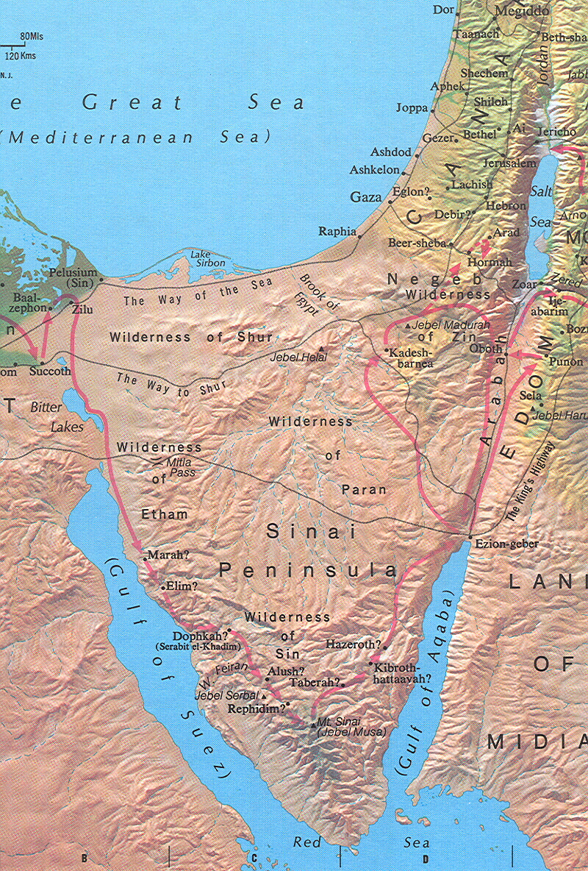

II. The Establishment of the Mosaic Covenant at Sinai (19:1–24:11)
A. The Covenant Concept Proposed by God through Moses midst suitable preparations (ch. 19)
The purpose of the covenant for the redeemed nation of Israel was so that they could obey the law to be given and thereby be God's “treasured possession, . . . a kingdom of priests and a holy nation” for God (19:5-6).

B. The Decalogue (20:1-17)
Here the covenant stipulations in the moral area are clearly stated.

- The Reaction of the People to God’s Fiery Presence (20:18-21)

D. The Book of the Covenant (20:22–23:33)
- Prologue: the basic principles of worship in Israel (20:22-26)

2. The fundamental rights of the Israelites (21:1–23:19)
i) Laws on slaves (21:1-11)
ii) Laws on homicide [including kidnapping and cursing parents] (21:12-17)
iii) Laws on bodily injuries (21:18-32)
iv) Laws on property damage [including animals, theft, and loss of value] (21:33-22:15)
v) Laws on society/proper conduct (22:16-31)
vi) Laws on justice and neighborliness (23:1-9)
vii) Laws on sacred festivals [Sabbatical year and three yearly feasts] (23:10-19)
- Epilogue: the relation of Yahweh to Israel as they prepare to claim the Promised Land (23:20-33)

- Ratification of the Covenant (24:1-11)

III. Directions regarding God's dwelling among His people (24:12–40:38)
A. Preparations for the revelation of these directions (24:12-18)
B. Instructions concerning the Tabernacle (chs. 25–31)
1. Collection of the materials (25:1-9)
2. Tabernacle furnishings (25:10-41)
i) Ark and atonement cover (25:10-22)
ii) Table of the bread of the Presence (25:23-30)
iii) Gold lampstand (25:31-40)
3. Tabernacle Structure: curtains and frames (ch. 26)
4. Altar of burnt offering (27:1-8)
5. Courtyard of the tabernacle (27:9-19)
6. Oil for the Lampstand (27:20-21)
7. Priesthood (28:1–29:46)
i) Official Establishment of the Priests: Aaron and his sons (28:1-5)
ii) Garments of the priests (28:6-43)
iii) Ordination of the priests (ch. 29)
8. Instructions for the services at the tabernacle (30:1-38)
i) Altar of incense (30:1-10)
ii) Ransom/census tax (30:11-16)
iii) Bronze basin for washing(30:17-21)
iv) Anointing oil (30:22-33)
v) Incense (30:34-38)
9. Appointment of tabernacle craftsmen (31:1-11)
10. Sign of the Sabbath (31:12-17)

11. Presentation of the tablets of the Testimony in stone (31:18)
C. The Breaking and Renewing of the covenant (chs. 32–34)
- The golden calf incident (32:1-29)

- Moses' intercession (32:30-35)

- Threatened separation and Moses' prayer to re-establish fellowship (ch. 33)

4. Renewal of the covenant (ch. 34)
D. The Construction and Dedication of the Tabernacle and Associated Objects (chs. 35–40)
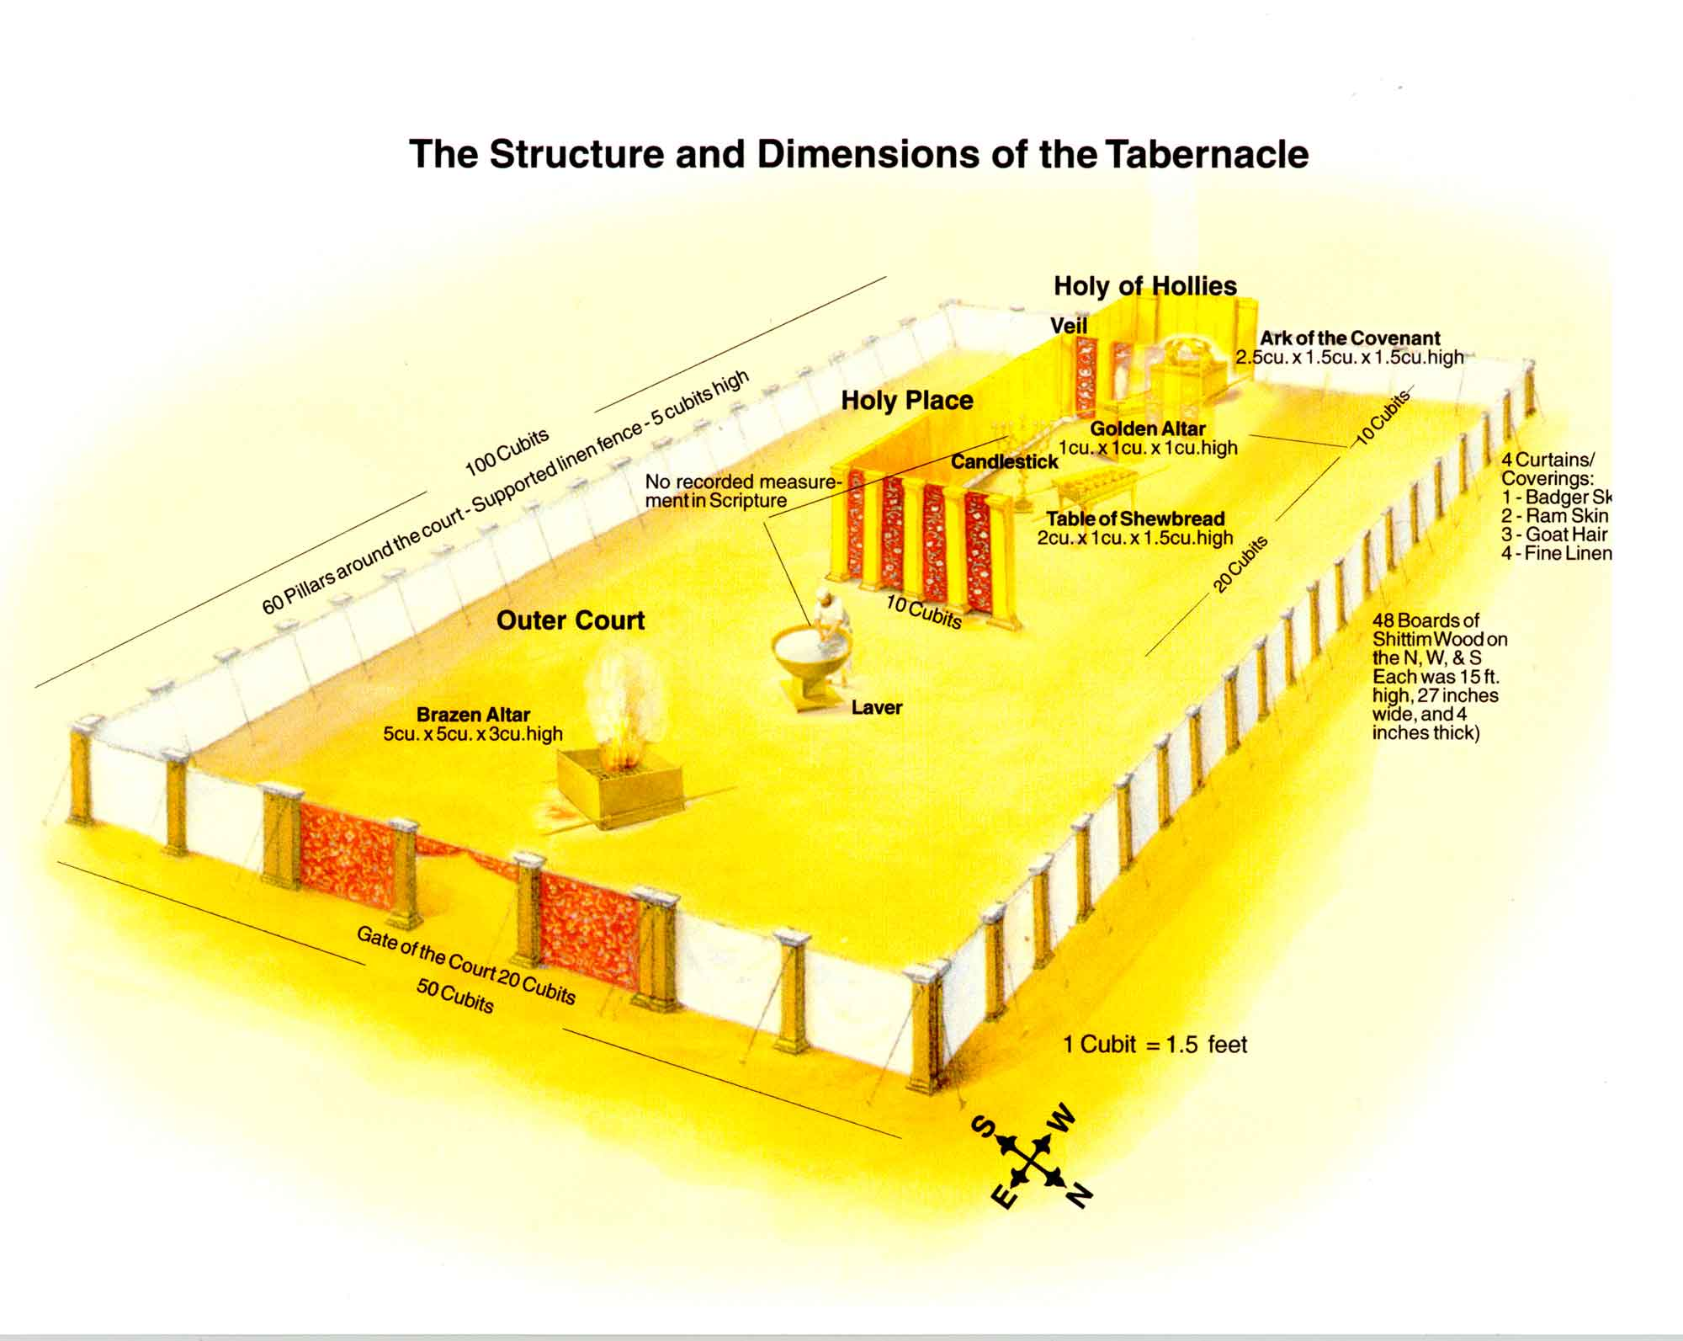

- Reiteration of the Sabbath regulations before building began (35:1-3)

2. Summons to build (35:4-19)
3. Voluntary gifts of materials for the tabernacle (35:20-29)

4. Bezalel and his craftsmen are recognized as being gifted by God (35:30–36:1)
5. The contributions by the people are restrained due to excess (36:2-7)

6. Progress of the work (36:8–39:31)
i) The construction of the tabernacle (36:8–38:20)
ii) An estimation of materials used (38:21-31)
iii) The fabrication of the garments of the high-priest and other priestly garments (39:1-31)
- Moses' inspection and blessing (39:32-43)

8. Erection of the tabernacle (40:1-33)

9. Dedication of the tabernacle: the glory of the LORD enters the tabernacle (40:34-38)

John D. Hannah, “Exodus” in The Bible Knowledge Commentary, Old Testament. (Wheaton, IL: Victor Books, 1985), 105-6.

