NEHEMIAH

Message:
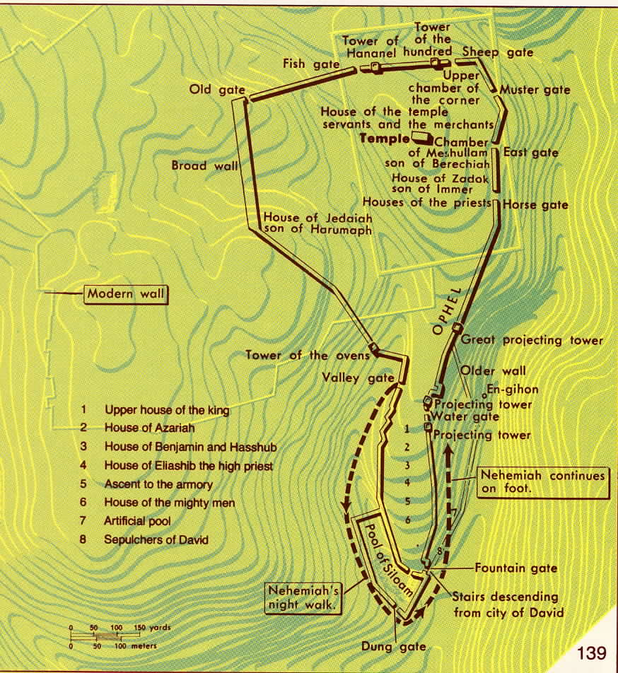
Nehemiah’s restoration of Jerusalem establishes the identity of the city and separates the people to God.

[Nehemiah highlights Yahweh’s faithfulness and thereby instills hope in postexilic Israel by demonstrating God’s providential working among human kings and governments. He restored Jerusalem physically and spiritually, affirming Yahweh’s promises to renew the remnant of Israel and to identify himself again with the city of Jerusalem.]

Relation of the Books of Ezra and Nehemiah:
Although the caption to Nehemiah 1:1, “The words of Nehemiah son of Hacaliah,” indicates that Ezra and Nehemiah were originally two separate compositions, they were combined as one in the earliest Hebrew manuscripts. Josephus (c. A.D. 37-100) and the Jewish Talmud refer to the book of Ezra but not to a separate book of Nehemiah. The oldest manuscripts of the Septuagint also treat Ezra and Nehemiah as one book. It titles this composite book Esdras B or 2 Esdras in contradistinction to the apocryphal 1 Esdras.
Origen (A.D. 185-253) is the first writer known to distinguish between two books, which he called I Ezra and II Ezra. In translating the Latin Vulgate (A.D. 390-405), Jerome called Nehemiah the second book of Esdrae (Ezra). The English translations by Wycliffe (1382) and Coverdale (1535) also called Ezra “I Esdras” and Nehemiah “II Esdras.” The same separation first appeared in a Hebrew manuscript in 1448.
Ezra along with Nehemiah provides the last inspired chronological record in the Old Testament period. Together they provide one account of the “new exodus” from Babylon to rebuild the temple, walls, and community.

Author:
This book is difficult to assign authorship or editorship for its final form. It is clearly based on Nehemiah’s first-hand memoirs, especially 1:1-7:72a and 11:1-13:31. The section of chapters 8-10 appear to continue Ezra’s memoirs.
Nehemiah was a Jewish servant (cup-bearer) to the king of Persia (King Artaxerxes I [464-424 B.C.]). He is named as the son of Hacaliah (1:1) but nothing is known of his background or family (except for his father’s name mentioned above and his brother’s name—Hanani [1:2]).
Most scholars in the past concluded that the author /compiler of Ezra and Nehemiah was also the author of 1, 2 Chronicles. This viewpoint is based on certain characteristics common to both Chronicles and Ezra-Nehemiah. The verses at the end of Chronicles and at the beginning of Ezra are virtually identical. Both Chronicles and Ezra-Nehemiah exhibit a fondness for lists, for the description of religious festivals and for such phrases as “heads of families” and “the house of God.” Especially striking in these books is the prominence of Levites and temple personnel. The words for “singer,” “gatekeeper,” and “temple servants” are used almost exclusively in Ezra-Nehemiah and Chronicles. Often, though not always, this author/compiler is argued to be Ezra.

Recipient(s):
No recipient is stated. The content would indicate that this book was intended for the postexilic Jewish remnant.

Date of Writing:
If Ezra was compiled shortly after the events of the book it may be dated c. 440 B.C. and the Nehemiah memoirs c. 430. The following dates are relevant to the postexilic history covered by the biblical books.

Date | Event | Reference
605, 597, 586 B.C. | Three deportations and final fall of the Southern Kingdom (Judah) | 2 Kings 24-25
538 B.C. | 1st Return under Sheshbazzar  -start to rebuild the temple | Ezra 1-6
520 B.C. | Haggai prophesies | Haggai
520-515 B.C. | Zechariah prophesies | Zechariah
516 B.C. | Temple completed | Ezra 6:13-22
c. 483-473 B.C. | Esther | Esther
458 B.C. | 2nd Return under Ezra | Ezra 7-10
444 B.C. | 3rd Return under Nehemiah  -rebuilt the city of Jerusalem | Nehemiah 1-7
 | Revival of the People | Nehemiah 8-12
426 B.C. | Nehemiah’s Second Return and Final Reforms | Nehemiah 13

Historical Context:
In 539 , Cyrus the king of Persia conquered the Babylonian empire and subsequently decreed that foreigners, including the Hebrews, could return to their land. The book of Nehemiah begins its record of events approximately thirteen years after Ezra’s reforms which were 80 years after the first return and re-establishment of temple worship.
The book of Nehemiah covers approximately fifteen years from 444-430 B.C. It documents the efforts of Nehemiah to restore both the spiritual values of the community and their identity as a nation by rebuilding Jerusalem. When the original exiles returned home they found the temple and city (Jerusalem) in ruins. At their first return the Jews, under Zerubbabel (Ezra 1-6) in 538 B.C., rebuilt the temple reestablishing the spiritual center of the community. The second return under Ezra (Ezra 7-10) in 458 B.C. led to a return to the covenant relationship with God. But the walls of the “City of God” (Jerusalem) continued to be a shamble. The walls were a symbol to the Jews of their identity as a nation and were also a visible sign to the surrounding nations of the return of Jewish nationhood. The third return, led by Nehemiah in 444 B.C., was in direct response to the need to rebuild the walls of Jerusalem and subsequently to again restore the people.
The sustained attack on priestly privileges by Ezra and Nehemiah was not to prevail. After 400 B.C. the power of the Jerusalem priesthood gradually became dominant and the divine theology which had prompted Ezra-Nehemiah became one of popular rather than hope, being taken up about 150 B.C. in the form of the Pharisaic movement.

Descriptive Outline:
I. Nehemiah’s First Administration (chs. 1-12)
A. Rebuilding the Walls in Jerusalem [Initial Separation of the Remnant for Blessing by Yahweh] (1:1-7:73)
1. The Return to Jerusalem (1:1-2:20)
a. News of the plight of Jerusalem (1:1-4)
b. Nehemiah’s Response: prayer (1:5-11)
c. The Commission of King Artaxerxes (2:1-8)
d. The journey itself (2:9-10)
e. Nehemiah’s Nighttime inspection of the walls (2:11-16)
f. His exhortation to the Jews to rebuild Jerusalem (2:17-18)
g. The opposition of Sanballat, Tobiah and Geshem (2:19-20)
2. The Work of Rebuilding (3:1-7:4)
a. List of the Builders of the Wall (ch. 3)
i. The northern section (3:1-7)
ii. The western section (3:8-13)
iii. The southern section (3:14)
iv. The eastern section (3:15-32)
b. Opposition to Rebuilding the Wall (ch. 4)
i. The mockery/derision of Sanballat and Tobiah (4:1-5)
ii. The threat of attack (4:6-15)
iii. Rebuilding the wall (4:16-23)
c. Social and Economic Problems (ch. 5)
i. The complaints of the poor concerning extortion (5:1-5)
ii. The cancellation of debts (5:6-13)
iii. Nehemiah’s unselfish example (5:14-19)
d. The Wall Rebuilt Despite Continued Opposition (ch. 6)
i. Attempts to snare Nehemiah by trickery and slander (6:1-9)
ii. The hiring of false prophets (6:10-14)
e. The completion of the wall (6:15-19)
f. Provisions for the protection of Jerusalem (7:1-3)
3. The Register of the People (7:4-73 a)
a. Nehemiah’s discovery of the list of returnees (7:4-5)
b. The returnees delineated (7:6-72)
c. Settlement of the exiles (7:73 a)

B. Ezra’s Preaching and the Outbreak of Revival (7:73 b-10:39)
1. The public exposition of the Scriptures (7:73 b-8:8)
2. The initial response of the people in Sorrow and then Joy (8:9-12)
3. The Celebration of the Feast of Tabernacles (8:13-18)
4. A day of Repentance: fasting, confession and prayer (9:1-5 a)
5. A recital of God’s dealings with Israel (9:5 b-31)
6. Confession of sins (9:32-37)
7. Ratification of a Covenant based on the Scriptures (9:38)
8. A list of those who sealed it (10:1-29)
9. Provisions of the Covenant (10:30-39)
C. Jerusalem is Populated and Dedicated So that Yahweh Can Again Bless His Chosen People [Partial Completion of the Separation of the Remnant for Blessing] (11:1-12:47)
1. New residents for Jerusalem (11:1-24)
a. Introductory remarks (11:1-4 a)
b. Residents from Judah (11:4 b-6)
c. From Benjamin (11:7-9)
d. From the priests (11:10-14)
e. From the Levites (11:15-18)
f. From the temple staff (11:19-24)
2. New residents for Judah (11:25-36)
a. Places settled by those from Judah (11:25-30)
b. Places settled by those from Benjamin (11:31-35)
c. Transfer of Levites from Judah to Benjamin (11:36)
3. Lists of Priests (12:1-26)
a. Priests and Levites from the first return (12:1-9)
b. High priests and Levites since Joiakim (12:10-26)
4. Dedication of the wall of Jerusalem (12:27-43)
5. Regulation of the temple offerings and services (12:44-47)
II. Nehemiah’s Second Administration (ch. 13)
A. Abuses during His Absence (13:1-5)
1. Mixed marriages (13:1-3)
2. Tobiah’s occupation of the temple quarters (13:4-5)

B. Nehemiah’s Return (13:6-9)
1. His arrival (13:6-7)
2. His expulsion of Tobiah (13:8-9)
C. Reorganization and Reforms (13:10-31)
1. Offerings for the temple staff (13:10-14)
2. The abuse of the Sabbath (13:15-22)
3. Mixed marriages (13:23-29)
4. Provisions of wood and firstfruits (13:30-31)

JERUSALEM/ZION

The following material is a summary of the material found in Theological Wordbook of the Old Testament, 764-5.

-the sanctity of Jerusalem Zion resides in the fact that Yahweh has chosen to dwell there. It was not set apart as holy at creation and does not possess any intrinsic holiness. It has become chosen and therefore important to the Lord and Israel only within history (cf. Ps 78:68-69). Hence it acquired meaning and sacredness.

Literal City
-Zion is that fortified mount between the Kidron valley (to the east) and the Tyropean valley (to the west) that David captured from the Jebusites (2 Sam 5:7; first reference to Zion). Subsequently it became known as the city of David (2 Sam 5:9).
-even before David captured this city it is spoken of in Genesis as a special place (see refereces below).
-in Genesis 14:18-20, “Melchizedek king of Salem . . . a priest of God Most High” blessed Abram and received a tithe (1/10) of all that Abram had captured (cf. Heb 7). “Salem” is a shortened form of “Jerusalem” (see Ps 76:2) and is related to the Hebrew word for “peace” (Shalom).
-Mount Moriah is specified as the place where Abraham offered up Isaac (Gen 22) which in 2 Chronicles is identified as the same place where the Lord appeared to David, the threshing floor of Araunah the Jebusite (Gen 22:2, 14; 1 Chr 22:1; 2 Chr 3:1).
-in Deuteronomy 12, the Lord instructed the Israelites that they were “to seek the place the LORD your God will choose from among all your tribes to put his Name there for his dwelling.”
-Jerusalem, the city of the Jebusites, seems to have been taken by Joshua and then subsequently lost (Judges 1:8, 21).
-the temple was built by Solomon to the north of the original fortified city and as the area of the city expanded the name of Zion continued to be applied to the entire city.
-Zion therefore can refer specifically to the temple vicinity or more generally to Jerusalem itself.
-the city of Zion became the center of Yahweh’s activities from the time Solomon built the temple here. Yahweh identified himself as “the One who dwells on Mount Zion” (Isa 8:18). It is from Zion that Yahweh initiates his judgment against sin (Amos 1:2)
-Zion as a city fell to the Babylonians in 586 B.C. The fall is described in Jeremiah 39; 52; Ezekiel 24; 33; and 2 Kings 25.
-Lamentations frequently refers to Zion and “the daughter of Zion/Daughter Zion” to express sorrow at Zion’s destruction (Lam 1:4, 6, 17, etc.)
-in exile the Psalmist was so despondent that he could not bring himself to sing any of the songs of Zion (Ps 137:1-6)
-but even in exile the people had faith and prayed for Yahweh to rebuild his city and to restore its fortress (Ps 102:13, 16; 69:35).

Theologically
-Zion sometimes includes the entire nation, the covenant community itself (Isa 1:27; Ps 97:8).
-Zion appears frequently in Psalms and Lamentations
-Zion seldom refers to the political capital of Judah (Jerusalem is used for this), but much more often stands for the city of God in the new age.
-Zion frequently occurs in poetic passages, referring to the temple area where Yahweh dwells. Psalm 48 renders great praise to Mount Zion and Psalm 87 speaks of the “glorious things spoken of Zion, city of God”.
-Zion will be the religious center, not only for Israel, but for the entire world (Isa 2:2-3; 4:2-6; and see below).
-Ezekiel seems to refer to Zion as the “navel” of the earth, the place where God sustains this planet (38:12). Theologically Zion is both the center of the land of Israel and the center of the earth.

Eschatologically
-in some of the prophets, especially Isaiah, Jeremiah, Joel, and Zechariah, Zion appears as the central location for Yahweh’s great deeds of salvation in the future.
-he will cleanse away Zion’s sin by judgment (Isa 4:4); that is the city will be redeemed by justice and righteousness (Isa 1:27; 33:5).
-God will build the city by laying a precious cornerstone in Zion (Isa 28:16)
-the glory of Yahweh that was present in the Exodus shall return to protect its inhabitants from the elements (Isa 4:5-6).
-God will firmly secure the city from its enemies (Isa 33:20)
-God’s people will return in joy and singing from the various places of their exile (Isa 35:10; 51:11). Then they shall weep no more (Isa 30:19).
-the land surrounding Zion will become as fruitful and lush as the Garden of Eden (Isa 51:3).
-the scope of this restoration is for all peoples; foreign nations shall come to Mount Zion to worship (Isa 2:3; Mic 4:2).
-all of these fantastic changes in Zion will give her the new name “My delight is in her” (Isa 62:1-5). But the greatest difference is that God himself will reign there in that day (Zech 8:3; Isa 59:20)

-after the 1,000 year Millennial Kingdom and the Great White Throne (Rev 20), the Holy City which comes down out of heaven from God is called the new Jerusalem (Rev 21:2).
-this New Jerusalem seems to combine elements of Jerusalem, the temple and the Garden of Eden

The duplicate lists of returning Jews as recorded in Ezra 2 and Nehemiah 7 also support two separate compositions.

