GENESIS


Message:
“Genesis shows us God’s original purpose for mankind and the first stages of God’s plan to bring man back to this purpose (including his choosing of Abraham’s descendants to do this).”

Title:
Each book of the Torah or Pentateuch (first five books of the Old Testament) originally received its title from the first word or words in the book. For the book of Genesis, the Hebrew word translated “in the beginning” is tyvarb (beresit). The English title “Genesis” is a transliteration of the Greek word used in the Septuagint translation. This Greek word, Gevnesiı (geneseos) is a translation of the key Hebrew term twdlwt (toledot). This Hebrew word is found in 2:4; 5:1; 6:9; 10:1; 11:10, 27; 25:12, 19; 36:1, 9; 37:2. It is translated into the English as “account” or “generations.”

Authorship:
The authorship of Genesis, as well as the rest of the Pentateuch, has been the subject of much debate ever since Baruch Spinoza, a Jewish-Dutch philosopher, introduced “higher criticism” of the Bible in the seventeenth century A.D. The “documentary hypothesis,” which developed from his work, is the theory that the Pentateuch was a compilation of selections from several different written documents composed at different places and times over a period of five centuries, long after Moses. A redactor (editor) or redactors combined these documents into the form that we have now. The major documents came to be known as J, E, D, P which represent a Yahwistic tradition, an Elohistic tradition, a Deuteronomic tradition, and a Priestly tradition.
The authorship controversy affects at least two main bodies of evidence. First, internal evidence which would give support to a unity of the first five books (this will be discussed below under the structure of Genesis); second, evidence from the rest of Scripture, especially Christ’s own words in the New Testament, would show that Moses wrote the Pentateuch (e.g., Preexilic references—Josh 8:31; 23:6; 2 Kgs 14:6; Postexilic references—Ezra 6:18; 7:6 [cp. 7:10-11]; Neh 8:1; 13:1; 2 Chr 25:4; 35:12; New Testament references—Matt 19:8; Mark 7:10; Luke 16:29-31; 20:37; 24:27; John 7:19). While the specific book of Genesis is not singled out, in the time of Jesus the Jews regarded the Pentateuch (Torah) as a whole unit. Consequently the hearers would have understood what Jesus said about any of the five books of Moses as an endorsement of the Mosaic authorship of them all.
Because Genesis ends approximately 300-400 years before Moses lived, the material must have been “compiled” by Moses based on either by direct revelations alone or with historical records.

Recipients:
Although the recipients are not named, if one accepts Mosaic authorship, as most evangelicals do, then the book was written initially either for the Israelites who were part of the group that left Egypt and hoped to enter the Promised Land from Kadesh-Barnea or, if written later in Moses’ life, the Israelites who were part of the group looking forward to entering the Promised Land from the Plains of Moab. For either group, the book would have encouraged the Israelites to trust their faithful, omnipotent God.
But this initial group of Israelites were not the exclusive group for whom the material of Genesis and the rest of the Pentateuch was written. It is clear that various teachings in Genesis were to be the basis of how mankind and specifically his people were to think of themselves, of sin, of their relationship to Almighty God. It remains relevant information for all people, and without Genesis much teaching in later revelation, including the New Testament, would be unclear or unintelligible.

Date of Writing:
If one accepts Mosaic authorship, the date of composition of Genesis must be within Moses’ lifetime (c. 1525-1405 B.C.) and specifically during the time of the wilderness wanderings (1446-1406 B.C.). For those who accept a later dating of the Exodus (e.g., 1220-1180 B.C.) then Genesis would be written during this period (for more information of the dating of the exodus, see Exodus: Date).

Date of Materials Presented:
The events recorded in Genesis stretch historically from the creation to Joseph’s death. If the genealogies in Genesis are taken as “closed” (i.e., with no gaps) then the minimum period from the end of creation to Israel’s entry into Egypt would be some 2,328 years making the creation of the world some 6168 years ago. If there are gaps then the time period could be extended considerably and made to fit more closely with the more commonly accepted belief among conservatives that mankind has been on the earth some 10,000 years (Egyptian history appears to go back to 3,500 B.C.).
The period covered by the creation account itself is, of course, subject to much controversy. If present scientific “facts” are taken as true, then the earth is millions of years old. Interpreters believing such “facts” are compelled to interpret Scripture in light of such. This is done in numerous ways including the gap theory (restitution theory), initial chaos theory (traditional view), and precreation chaos theory. In addition, the days of creation are seen as either short (literal 24 hour day theory), long (day-age or geologic day theory; literal days with intervening ages theory), or unrelated to time (revelatory day theory).

Purpose:
The general purpose of Genesis is to provide an accurate record of the purpose for and the history of the beginning of God’s sovereign establishment of his covenant of blessing with his elect people. The context of the covenant must includes the beginning and establishment of the earth and the human race, the fall of mankind in sin, the resulting judgments and the means by which God, through his created beings (mankind), would seek to reestablish His rule over creation by man’s conflict with evil.
This would both instruct and prepare Israel concerning her heritage of promise as well as promote faithfulness to Yahweh.

Literary Structure/Outline:

-toledot (the generations of/ the account of) occurs throughout the book and introduces a new section.
-Gen 2:4; 5:1; 6:9; 10:1; 11:10; 11:27; 25:12; 25:19; 36:1 (36:9); 37:2

1. Introduction—the story of creation 1:1-2:3
2. What became of creation 2:4-4:26
3. What became of Adam 5:1-6:8
4. What became of Noah 6:9-9:29
5. What became of Noah's sons 10:1-11:9
6. What became of Shem 11:10-26
7. What became of Terah 11:27-25:11
8. What became of Ishmael 25:12-18
9. What became of Isaac 25:19-35:29
10. What became of Esau 36:1-37:1
11. What became of Jacob 37:2-50:26

PRIMEVAL EVENTS 1:1-11:26

I. Introduction—the story of creation 1:1-2:3
- Summary statement of creation 1:1

FOUR VIEWS OF CREATION
(see textbook by Benware, Note B pages 286-88)

Atheistic Evolution
Everything in the universe has come into existence and has evolved into its present form as a result of natural processes unaided by any supernatural power.

Theistic Evolution
Everything in the universe has come into existence and has evolved into its present form as a result of natural processes guided by the God of the Bible.

Creationism:
Day-Age View Creationism
God created the world directly and deliberately, without leaving anything to chance, but He did it over long periods of time that correspond roughly to the geological ages.

Literal Day or Six Day Creationism
Genesis 1 describes one creative process that took place in six consecutive 24 hour periods of time not more than 6,000 to 15,000 years ago.

Ruin-Reconstruction View or Gap Theory
Between Genesis 1:1 and 1:2 there was a long, indeterminate period in which we can locate [the destruction of an original world and] the unfolding of the geological ages.
This could be combined with the previous three views.

- The Conditions at the time of creation 1:2

- The Six days of creation 1:3-31

FUNDAMENTAL
LITERARY PATTERN
in Genesis 1

1.Announcment "And God said"

2.Command "Let there be/let it be
gathered/let it
bring forth"

3.Report "And it was so"

4.Evaluation "And God saw that it was
good"

5.Temporal Framework "And there was evening and
there was morning—the #
day"

HORIZONTAL LITERARY
ARRANGEMENT
Genesis 1:3-2:3

#1 light #4 luminaries

#2 sky/separation #5 fish/birds
of waters

#3 land/vegetation #6 animals/
man

#7 Sabbath

- The Seventh day (Sabbath) 2:1-3

II. What became of creation 2:4-4:26

A. The Creation of man and woman 2:4-25

B. The Fall 3:1-6

C. The Judgments (justice and mercy) after the Fall 3:7-24

D. Effect of the Fall on Adam's sons (Cain and Abel) 4:1-16

E. The Spread of civilization (both ungodly and Godly) 4:17-26

III. What became of Adam 5:1-6:8

A. Genealogy of Adam through Seth down to Noah 5:1-32

B. Increase of wickedness on the earth 6:1-8

IDENTITY OF THE "SONS OF GOD" (GEN 6:1-4)

A biblical-theological problem!

ITEMS | THEORY #1 | THEORY #2 | THEORY #3 | THEORY #4
"Sons of God" | Fallen angels | Godly line of Seth | Dynastic rulers (possibly ungodly) | Non-elect despots under demonic influence
"Daughters of men" | Beautiful mortal women | Depraved Cainite line | Commoners (became a sort of royal harem?) | Wives of elect mankind
Sin | Marriage: angelic with man | Marriage: Sethites with Cainites | Marriage: Ungodly princes expand | Mix of groups God separated, elect/demon
Result | Monstrous giants | Wicked humanity with no godly line left except Noah to bring the seed who would conquer the evil one who was behind the serpent | Dynastic rulers | Nephilim (all killed in the Flood)
Evidence | -the phrase "sons of God" in the remainder of the OT will consistently refer to Angelic beings (e.g. Job 1:6; 38:7; Ps 29:1; 89:6)  -the NT may refer to the Angelic sin of Genesis 6 in 2 Pet 2:4 (1 Pet 3:18-20); Jude 6-7  -the Book of First Enoch 6-7 says definitely they were angels  -the resultant unnatural race of monstrosities  -the judgment fits the perversion  -Jesus said that angels do nor marry IN HEAVEN; doesn't say they "cannot" ON EARTH (Matt 22:30)  -angelic beings can eat, perform human functions  -the parents were responsible for the marriages therefore the judgment was on all humans | -the concept of a godly line is seemingly established  -the Hebrew indicates overt continuity in Genesis 5-6 (context refers to both godly and ungodly lines, cf. 4:26; 5:24; 6:9)  -Luke 3:38 refers to "Adam, Son of God" which might indicate that the godly line would be known as "the sons of God"  -the theme and emphasis in the whole of Genesis on non-marriage between godly and ungodly  -the emphasis on men in the context (not angels)  -Mankind as the recipient of the Flood  -sees the mention of the Nephilim as signifying time, not the result of the marriages | -Lamech is a previous example of this sin  -magistrates and rulers are often referred to as "gods" [though not "sons of gods"] (Exod 21:6; 22:8-9; Ps 82:1,6)  -kings sometimes referred to as deities or half-gods in the Ancient Near East  -references in the context to the development of wicked dynasties  -reference in ancient accounts to origin of kingship prior to the Flood | -all of the proofs of the other views with the recognition that they are not exclusive of each other  -"Sons of God" mean both angels and kings at the time of writing  -in Genesis 6, the emphasis on the sin of men, but demons are clearly involved according to the NT (see verses under #1)  -explains "pollution" of the human race to prevent the "seed" for coming to conquer evil
Problems | -lends great mythological tone  -volitional and physiological impossibilities of an angelic marriage (man is a procreated being while angels are only created)  -the absence of angels being previously mentioned except in Eden  -the fact that mankind is punished for wickedness instigated by angels  -the NT support can be questioned  -how does the Flood prevent demonic intervention again? | -"Sons of God" never refers to mortal believers in the whole OT  -some question the fact that God had firmly established one such line yet  -the word for "men" in the expression "daughters of men" is general in 6:2, and would require further classification to be understood otherwise (as referring to ungodly men)  -the theory doesn't account for the other children of Adam (not of either the line of Seth or Cain)  -by the time of judgment Noah ALONE is righteous, though the sin of mixed marriages could have taken such a toll (the Flood then would not destroy any godly line)  -no record that there was a ban by God on intermarriages yet | -there is an imbalance between the sins of some leaders in some places, and the cosmic effect of the Flood (though not impossible if they were the leaders and developed tremendous power and authority over all mankind)  -the NT ties angelic sin to the time of the Flood (cf. #1-2)  -kingship is not expressed in this context  -outside of covenant terms, the OT never uses Kings in relation to sons of a deity (cf. Ps 2:6-7)  -needs the connection of verse 4 but the "mighty men" are the "Nephilim," not the children of the union | -ideally, each of the problems for the other views are solved by this combination of views
Advocates | Albright; Gaebelein; Kelly; Unger; Waltke; Delitzsch; Ambrose; Torrey; Bullinger; Von Rad; Josephus; Driver; Wuest; Pember; Philo; Cassuto; Gray | Leupold; Keil; Lang; Fausset; Jamieson; Lincoln; Strigers; Brown; Murray; Matthew Henry; Scofield; Baxter; Scroggie; Hengsterberg | Kaiser; Birney; Kline; Aramaic Targums; Rashi; Kober; Manfred; Cornfield; Ramban; Jacob | A. P. Ross

IV. What became of Noah 6:9-9:29

A. The Flood 6:9-8:22

FACTS CONCERNING THE ARK

Physical Dimensions: 350 cubits X 50 cubits X 30 cubits
3 decks or levels

Notes from Ryrie’s Study Bible (on Genesis 6:15):
Although we do not know the exact length of a cubit at this time, later it was about 18 inches (see note on 2 Chr. 32:30), making the ark 450 feet long, 75 feet broad, and 45 feet high, with a displacement of about 20,000 tons and gross tonnage of about 14,000 tons. Its carrying capacity equaled that of 522 standard railroad stock cars (each of which can hold 240 sheep). Only 188 cars would be required to hold 45,000 sheep-sized animals, leaving three trains of 104 cars each for food, Noah's family, and "range" for the animals. Today it is estimated that there are 17,600 species of animals, making 45,000 a likely approximation of the number Noah might have taken into the ark.
-the average size of a sheep has been chosen to take into account the largest animals (elephants, giraffes) and also the smallest (mice, insects). Many of the smaller could have lived among the larger without conflicts.
-the animals probably existed peacefully with each other before the Flood and would not need to have been separated.
-it may be that God brought some of the younger and smaller members of each species into the ark.
-it is also possible that God caused the animals to go into a deep sleep or hibernation.
B. The Noahic Covenant 9:1-17

C. The curse on Canaan 9:18-29

V. What became of Noah's sons 10:1-11:9

A. The genealogies of Japheth, Ham and Shem (through Joktan) 10:1-32

-notice there is an emphasis on the Canaanites

B. The dispersion at the tower of Babel 11:1-9

VI. What became of Shem 11:10-26

The genealogy of Shem (through Peleg) to Terah (and son Abraham)

PATRIARCHAL NARRATIVES (11:27–50:26)

VII. What became of Terah 11:27-25:11

A. Abram's obedience and Covenant 11:27-12:9

The unconditional covenant made with Abraham (Gen 15) incorporates seven elements which were part of the promise made in Genesis 12 and 15. These include the promise of:
1) making of Abraham into a great nation [great number of progeny] (12:2a)
2) blessing of Abraham [wealth] (12:2b)
3) making Abraham's name great [popularity] (12:2c)
4) you will be a blessing [others will gain wealth because of Abraham] (12:2d)
5) bless those who bless you (12:3a)
6) curse those who curse you (12:3b)
4b) all peoples on earth will be blessed through you [deliverance, spiritually] (12:3c)
7) a grant of land (12:7; 15:9-21)
These are what God promised to do for and through His chosen seed. All eight of these can be seen to be developed and fulfilled (at least in kind though not in extent) in Genesis 12-50.

B. Abram in Egypt 12:10-20

C. Abram and Lot separate 13:1-18

D. Abram militarily rescues Lot (n.b. Melechizedek)14:1-24

E. Reaffirmation/ratification of the Abrahamic Covenant 15:1-21

F. Birth of Ishmael 16:1-16

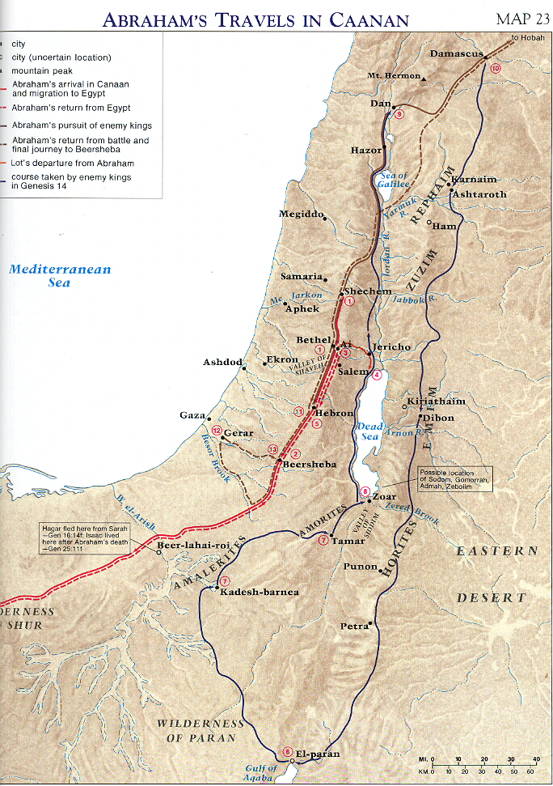
Map: Moody Bible Atlas (Chicago: Moody Press)

G. Sign of Abrahamic Covenant—Circumcision 17:1-27

H. Yahweh's visit to Abraham 18:1-15

I. Abraham's intercession for the righteous in Sodom and Gomorrah 18:16-33

J. Sodom and Gomorrah destroyed 19:1-29

K. The origin of the Moabites and Ammonites through Lot's daughters 19:30-38

L. Abraham and Abimelech at Gerar (Philistine territory) 20:1-18

M. The birth of Isaac 21:1-7

N. Hagar and Ishmael sent away 21:8-21

O. Abimelech's treaty with Abraham 21:22-34

P. The test of Abraham with the sacrifice of Isaac 22:1-19

Q. The descendants of Nahor (including Rebekah) 22:20-24

R. The death of Sarah and the purchase of her tomb 23:1-20

S. The choice of a bride (Rebekah) for Isaac 24:1-67

T. The death of Abraham 25:1-11

VIII. What became of Ishmael 25:12-18

IX. What became of Isaac 25:19-35:29

A. Isaac's twin sons (Jacob and Esau) 25:19-26

B. The sale of the birthright by Esau to Jacob 25:27-34

C. Isaac and Abimelech at Gerar (Philistine territory) 26:1-33

D. Jacob's deception in obtaining his father's blessing 26:34-28:9

E. Jacob's dream at Bethel 28:10-22

F. Jacob's marriages and Laban's deception 29:1-30

G. Jacob obtains 12 children 29:31-30:24

H. Jacob's desire to return and his new conflict with Laban 30:25-43

I. Jacob flees from Haran while Laban pursues 31:1-55

J. Jacob's preparations to appease Esau 32:1-21

K. Jacob wrestles with God at the Jabbok 32:22-32

L. Jacob meets Esau and return to Canaan 33:1-20

M. The rape of Dinah and the revenge of Shechem by Simeon and Levi 34:1-31

N. Jacob's return to Bethel 35:1-15

O. The death of Rachel (birth of Benjamin), sin of Reuben and the death of Isaac 35:16-29

X. What became of Esau 36:1-37:1

XI. What became of Jacob 37:2-50:26
A. Joseph treated by his father as favorite yet chosen by God as leader 37:2-11

B. Joseph sold by his brothers into slavery 37:12-36

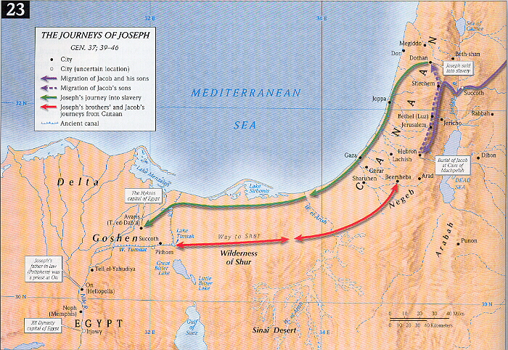
C. Judah and Tamar (the birth of Perez [chosen line] and Zerah) 38:1-30

D. Joseph, from Potiphar's house (and Potiphar's wife) to prison 39:1-23

E. The prisoner's dreams and Joseph's interpretations 40:1-23

F. Pharaoh's dreams and Joseph's interpretation 41:1-32

G. Joseph becomes an authority in Egypt 41:33-57

H. Joseph's brothers' first journey to Egypt 42:1-38

I. Joseph's brothers' second journey to Egypt 43:1-44:34

J. Joseph's reconciliation with his brothers 45:1-15

K. Israel's (Jacob's) move to Egypt 45:16-46:30

L. Joseph's care and leadership for his family and for his Pharaoh 46:31-47:27

M. Jacob's faith in the Abrahamic covenant 47:28-31

N. Jacob 'adopts' Manasseh and Ephraim and blesses them 48:1-22

O. Jacob blesses his sons 49:1-28

P. Deaths of Jacob and Joseph but a promise of a land yet to be fulfilled 49:29-50:26

The word Pentateuch is a Greek word meaning five books. These first five books of the Old Testament are called Torah by the Jews.
A classic rebuttal to the documentary theory can be found in Oswald T. Allis, The Five Books of Moses (Philadelphia: Presbyterian and Reformed Publishing Co.: 1943). For reviews from a conservative viewpoint of other subsequent approaches scholars have pursed in the study of Genesis (i.e., form-critical, tradition-historical, and rhetorical-critical) see Allan P. Ross, Creation and Blessing (Grand Rapids: Baker Book House, 1988), 27-35; Victor P. Hamilton, The Book of Genesis: Chapters 1-17 (Grand Rapids: William B. Eerdmans, 1990), 11-38.
This would be based on accepting the following time divisions: Adam [4174 B.C.] to the flood—1656 years; the flood [2518 B.C.] to Abraham—352 years; Abraham [2166 B.C.] to the journey to Egypt—320 years; the time in slavery in Egypt—400 years [1846-1446 B.C.].
This figure is arrived at by adding the 1994 years of the Common Christian Era, plus the 1446 years (taking an early date for the Exodus) back to the Exodus, plus the 400 years of slavery in Egypt, plus the 2328 years from the entry into Egypt back to Adam (see above footnote for further details.
Among many places the various views on creation or re-creation are surveyed and critiqued by Mark F. Rooker, “Genesis 1:1-3: Creation or Re-creation,” Bibliotheca Sacra 149 (July-Sept 1992): 316-23 and Bibliotheca Sacra 149 (Oct-Dec 1992): 411-427.
Many see these elements as incorporating basically three major concepts: land, seed, and blessing. By maintaining eight elements it seems easier to identify individual elements connected with the remaining stories in Genesis that demonstrate God's commitment to bringing each of these elements/blessings to Abraham's descendants.
A Royal Grant is an unconditional covenant made by a king's grant (of land or some other benefit) to a loyal servant for faithful or exceptional service. The grant was normally perpetual and unconditional, but the servant's heirs benefited from it only as they continued their father's loyalty and service. (Cf. 1 Sam 8:14; 22:7; 27:6; Esth 8:1.)

