NUMBERS

Message:
“Failure by the theocratic nation of Israel to respond in trust and obedience brings about both divine judgment and a hardening of the national heart.”

Title:
The English name of the book comes through the Latin Vulgate’s Liber Numeri and is based on the census lists found in chapters 1 and 26. Furthermore, “numbers” are involved in the tribal offerings at the dedication of the Tabernacle (ch. 7), the totals given for the number of sacrifices offered in the daily, weekly, and yearly festivals (chs. 28-29), the total number of dead from plagues (16:49; 25:9), the listing of plunder taken from the Midianites (31:32-47), and the number and size of the Levitical cities (ch. 35).
The Hebrew title of the book rbdmb (bammidbar, “in the desert”) is taken from the fifth word of the first verse and is also descriptive of its contents since Numbers presents an account of the 38-year period of Israel’s wandering in the desert following the establishment of the covenant of Sinai. For all those twenty or older when the nation rebelled at Kadesh Barnea, the desert became their burial site.

Author:
See Genesis: Author.
Numbers has traditionally been ascribed to Moses. This conclusion is based both on statements concerning Moses’ writing activity (e.g., 33:1-2; Exod 17:14; 24:4; 34:27) and on the assumption that the first five books of the Bible, the Pentateuch, are a unit and come from one author. There are evidences of style that would indicate an author who also wrote the rest of the Pentateuch. The frequent use of the phrase, “The LORD said/spoke to Moses” also gives weight to Mosaic authorship. The book also gives evidence that the author was an eyewitness of the events (e.g., 13:22) which would apply to Moses.
It is not necessary, however, to claim that Numbers came from Moses’ hand in the exact form that it now exists. Portions of the book could be added by scribes or editors from later periods of Israel’s history. For example, the protestation of the humility of Moses (12:3) would hardly be convincing if it came from his own mouth. But it seems reasonable to assume that Moses wrote the essential content of the book.

Recipient:
See Genesis: Recipient.
While Numbers is written for the nation of Israel, it is important to notice that unlike Genesis, Exodus, and Leviticus, the book of Numbers was written specifically for the children of those who had rebelled at Kadesh Barnea and therefore had not entered the promised land.

Historical Context:
Chronologically Numbers is a continuation of Israel’s experience in the wilderness introduced in Exodus. It builds on both the events of Exodus and the legislation of Leviticus. Israel is now ready to continue her journey to the Promised Land. Numbers 36:13 makes it clear that this book takes the history up to the time when Israel is waiting on Plains of Moab by the Jordan River. The scope of the book includes the organization and preparations of the nation for the departure from Mount Sinai, the journey from Sinai to Kadesh, the ensuing rebellion out of unbelief, the condemnation of forty years of wilderness living and death of the adults, and finally victories in the Transjordan and preparations to enter the promised land of Canaan.

Date:
See Exodus: Date.
Numbers was probably written on the plains of Moab beside the Jordan (36:13) though it is possible for parts of it to have been written before arriving there. This was approximately forty years (Deut 1:3) after the exodus (including almost a year at Mount Sinai, 1:1) and so, taking an early date, would be c. 1406 B.C.

Literary Features:
Numbers contains a variety of literary genres, not just a series of lists and ritual procedures. The census lists of chapters 1 and 26 form a kind of inclusio, giving the population totals at the beginning and end of the forty years of wilderness living. This is followed in the book with an appendix (chs. 27-36) including regulations on women’s rights (chs 27, 36, which act as an inclusio for this section). Too, the rebellion of the old generation in chapter 13 and the rebellion of the new generation in chapter 25 form an inclusio in regard to rebellion.
Geographically, the first ten chapters the Israelites are still at Mount Sinai, chapters 10 to 21 have Israel wandering in the desert, while chapters 22 to 36 have their setting on the Plains of Moab.
There is a great deal of literary arrangement in the various lists in Numbers, many times with extensive repetition for each tribe. While poetry is not extensive, it does occur in 6:24-26, 10:35-36, 21:17-18, 27-30; 23:7-10,18-24; 24:3-9, 15-24.

Purpose:
The purpose of this book is to encourage Israel’s corporate walk in covenant relationship which is initiated and ordered by Yahweh, but delayed and disrupted (though not dissolved) by Israel’s disobedience. What happens to Yahweh’s promises when there is national disobedience (giving into evil)? The promises remain but again the cycle of permission of evil, judgment, deliverance and blessing is seen as God in his grace continues to work with his people. This is seen most acutely in the Kadesh Barnea incident (Num 13-14).
I. final Preparations of THE THEOCRATIC NATION before Departing TO CONQUER the Promised Land (1:1–10:10)
A. The Commands for the Census of the People (chs. 1–4)
1. The numbers of men from each tribe mustered for war (ch. 1)

2. The placement of the tribes around the tabernacle and their order for march (ch. 2)

3. The placement of the Levites around the tabernacle, and the numbers of the Levites and the firstborn of Israel (ch. 3)

4. The numbers of the Levites in their tabernacle service for the Lord (ch. 4)

B. The Commands and Incidents at Sinai which show Obedience and Dedication of the People (5:1–10:10)
1. Removal of physical defilement from the camp (5:1-4)

2. Clarification on the requirement of restitution (5:5-10)
3. The law of jealousy and the need for pure, trustworthy relationships (5:11-31)

4. The Nazirite vow (6:1-21)

5. The Aaronic benediction (6:22-27)

6. The offerings of the 12 leaders at the dedication of the tabernacle (ch. 7)
7. The setting up of the lamps and the separation of the Levites (ch. 8)
8. The observance of the Passover (9:1-14)

9. The manner of guidance from the glory cloud (9:15-23)

10. The various uses of the silver trumpets (10:1-10)

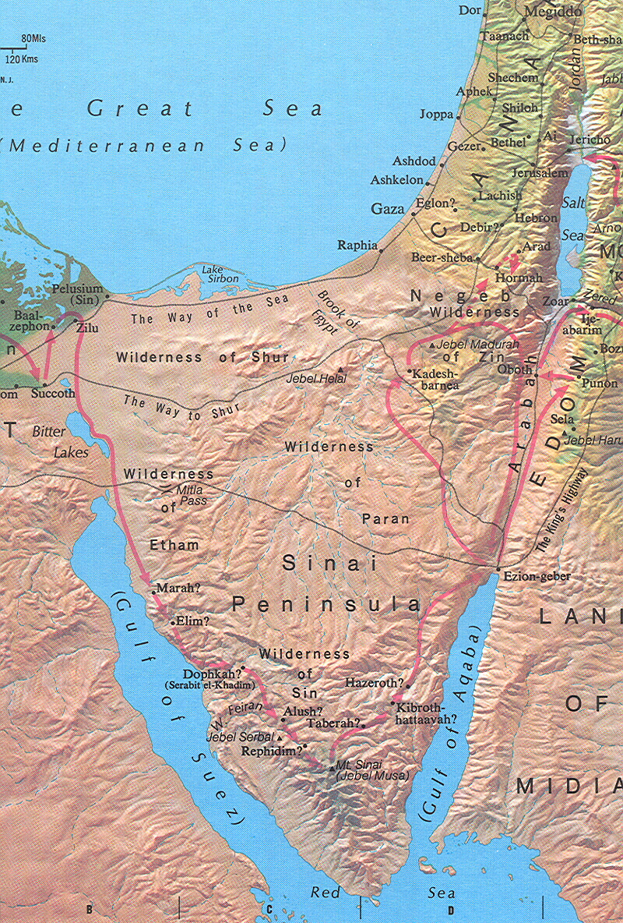
II. ISRAEL IN THE WILDERNESS, REBELLION RATHER THAN TRUST (10:11–25:18
A. The Journey from Sinai to Kadesh (10:11–12:16)
1. The Beginning of the Journey: God's Presence is acknowledged (10:11-36)

2. The Renewal of Complaining (ch. 11)

3. The Opposition of Miriam and Aaron to Moses (ch. 12)

B. Israel at Kadesh, the Delay Resulting from Rebellion (13:1–14:45)
1. The 12 Spies and Their Mixed Report of the Good Land (ch. 13)

2. The People’s Rebellion against God’s Commission, and Their Defeat (ch. 14)

C. Various Incidents of Rebellion and Legislations while under Judgment of God in the Wilderness (15:1–25:18)
1 Collection of Laws on Offerings, the Sabbath and Tassels on Garments (ch. 15)
2. The Rebellion of Korah and His Allies (ch. 16)

3. The Budding of Aaron’s Staff: A Sign for Rebels (ch. 17)

4. Concerning Priests, Their Duties and Their Support (ch. 18)
5. The Red Heifer and the Cleansing Water (ch. 19)

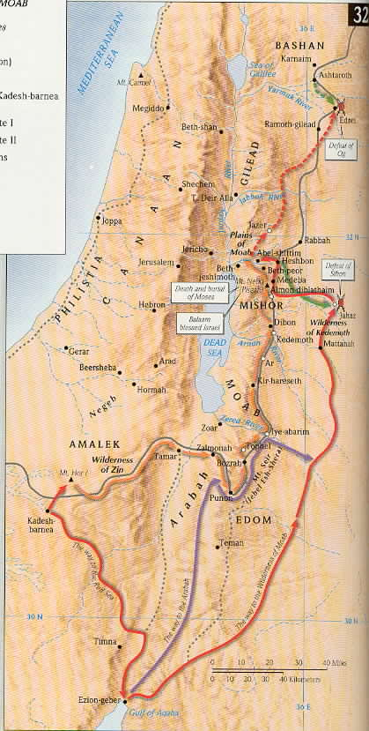

6. The Sin of Moses (20:1-13)

7. The Resistance of Edom (20:14-21)

8. The Death of Aaron (20:22-29)
9. The Destruction of Arad (21:1-3)
10. The Bronze Snake (21:4-9)

11. A record of Journey around Edom and through the land of Moab (21:10-20)
12. The Defeat of Sihon and Og (21:21-35)

13. Balak of Moab Hires Balaam to Curse Israel (22:2-41)

14. Balaam Blesses Israel in Seven Oracles (chs. 23–24)

15. The Baal of Peor and Israel’s Apostasy (ch. 25)

IIi. FINAL PREPARATIONS OF THE THEOCRATIC NATION BEFORE THEIR SECOND ATTEMPT AT DEPARTING TO CONQUER THE PROMISED LAND (Chs 26–36)
A. Instructions for the New Generation (chs. 26–30)
1. The Second Census (ch. 26)

2. The inheritance for women (27:1-11)
3. The successor to Moses (27:12-23)

4. Commands regarding offerings (28:1-15)
5. Commands regarding festivals (28:16–29:40)
6. Commands regarding vows (ch. 30)
B. The War against Midian (ch. 31)
C. The Settlement of the Transjordan Tribes (ch. 32)

D. Review of The Stages of the Journey (ch. 33)

E. The Land of Inheritance (chs. 34–35)
F. The Inheritance for Women (ch. 36)

